Captured parameters OR path parameters

Path parameters or captured parameters are send as part url
Path parameters are defined inside urls.py while defining url pattern for a view/resource
Path parameters are defined using angle brackets <>
This consist 2 parts
- Data type
- Parameter name

<datatype:parameter-name>

Datatype
- int
- float
- str
- slug

names of the path parameters must be equal to the name of the parameters defined inside view.

Define the view with parameters defined in urls.py

Path parameters support request method get or post.

Views.py
from django.shortcuts import render
from django.http import HttpResponse
# Create your views here.

def add(request,n1,n2):
n3=n1+n2
response=HttpResponse(f'<h2> Sum of {n1} and {n2} is {n3}</h2>')
return response
def result(request,rno):
stud_data={1:['naresh',60,70],
2:['suresh',70,90],
3:['ramesh',30,40]}
if rno in stud_data:
data=stud_data[rno]
result="PASS" if data[1]>=40 and data[2]>=40 else "FAIL"
output=f'<h2>Hello {data[0]}, and your result is {result}</h2>'
else:
output=f'<h2>Rollno {rno} is invalid</h2>'

response=HttpResponse(output)
return response

urls.py
from django.contrib import admin
from django.urls import path
from app1.views import add,result
urlpatterns = [
path('admin/', admin.site.urls),
path('add/<int:n1>/<int:n2>/',add),
path('result/<int:rno>/',result),
]

Settings.py
INSTALLED_APPS = [
'django.contrib.admin',
'django.contrib.auth',
'django.contrib.contenttypes',
'django.contrib.sessions',
'django.contrib.messages',
'django.contrib.staticfiles',
'app1'
]

What is difference between query parameters and path parameters?

Query Parameters | Path Parameters
Query parameters are also called query string | Path parameters are called captured parameters
It supports only one request method called GET | It support multiple http request methods (GET, POST)
Query parameters are concatenated with URL by separating with ? | Path parameters are defined as part url pattern
Query parameters are stored inside request object and send to view | Path parameters are not stored inside request object, it is send as a separate parameters list inside view
There is no configuration required inside urls.py | Configuration required inside url.py
Always data is send as string | Data type is defined for each parameter
In application development query string can be used for reading, updating, insertion or deleting resources | Path parameters are used to get resource or identify resource
Query parameter hold one or more than one value | Path parameter hold single value

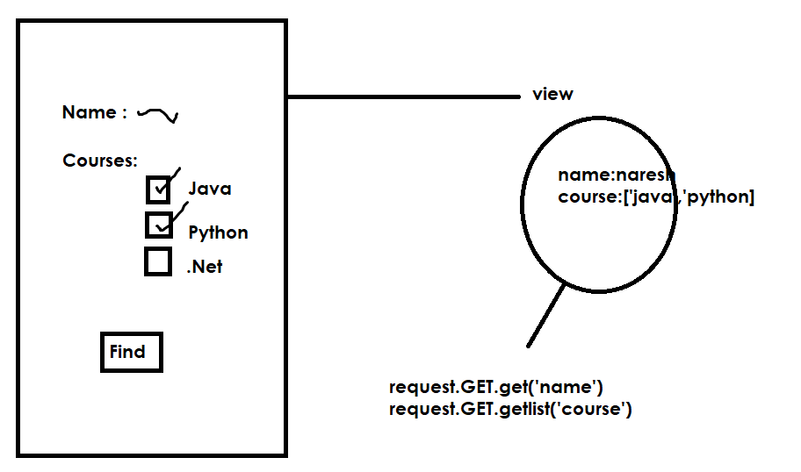

Views.py
from django.shortcuts import render
from django.http import HttpResponse
# Create your views here.
def find_fee(request):
name=request.GET.get("name")
course=request.GET.getlist("course")
output=""
for c in course:
if c=="python":
output+="Python Fees:5000<br>"
elif c=="java":
output+="Java Fees :2000<br>"
elif c=="net":
output+=".Net Fees :1000<br>"

response=HttpResponse(f'Hello {name}, {output}')
return response

def home(request):
response=render(request,"home.html")
return response

home.html
<!DOCTYPE html>
<html lang="en">
<head>
<meta charset="UTF-8">
<meta name="viewport" content="width=device-width, initial-scale=1.0">
<title>Document</title>
</head>
<body>
<table border="2" width="50%">
<form action="/find">
<tr>
<td>StudentName</td>
<td><input type=text name="name"></td>
</tr>
<tr>
<td>Courses</td>
</tr>
<tr>
<td><input type="checkbox" name="course" value="java">Java</td>
<td><input type="checkbox" name="course" value="python">Python</td>
<td><input type="checkbox" name="course" value="net">.Net</td>
</tr>
<tr>
<td><input type="submit" value="find"></td>
<td><input type="reset" value="clear"></td>
</tr>

</form>
</table>
</body>
</html>

Urls.py
from django.contrib import admin
from django.urls import path
from app1.views import home,find_fee
urlpatterns = [
path('admin/', admin.site.urls),
path('',home),
path('find/',find_fee),
]

Settings.py
INSTALLED_APPS = [
'django.contrib.admin',
'django.contrib.auth',
'django.contrib.contenttypes',
'django.contrib.sessions',
'django.contrib.messages',
'django.contrib.staticfiles',
'app1'
]

TEMPLATES = [
{
'BACKEND': 'django.template.backends.django.DjangoTemplates',
'DIRS': [BASE_DIR/"templates"],

